BIRDVILLE HIGH SCHOOL

2021 CHAMPION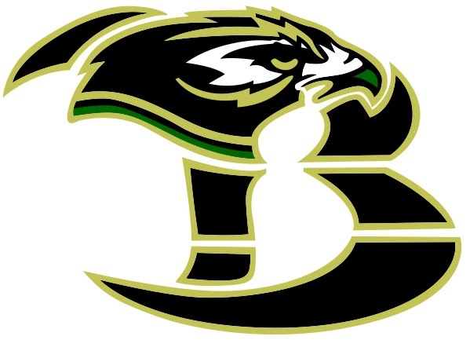UILDER PERFORMANCE CAMP

OPEN TO: ALL MALE AND FEMALE ATHLETES ENTERING GRADES 7-12 IN AUGUST 2021. The student must have a CURRENT PHYSICAL / MEDICAL HISTORY form.

WHERE: BIRDVILLE HIGH SCHOOL

WHEN: WEEK 1: JUNE 7 – 10
WEEK 2: JUNE 14 – 17
WEEK 3: JUNE 21 – 24
WEEK 4: JUNE 28 – JULY 1
THERE IS NO CAMP THE WEEK OF July 5TH – 9TH
WEEK 5: JULY 12 – 15
WEEK 6: JULY 19 – 22
WEEK 7: JULY 26 – 29

TIMES: MALES (10th – 12th Grades) - 7:00 A.M. TO 8:30 A.M.
MALES (7th – 9th Grades) -- 8:45 A.M. TO 10:00 A.M.
FEMALES (7th – 12th Grades) – 10:15 A.M. TO 11:30 A.M.

WHAT TO Individualized strength development program as well as implementations of
EXPECT: flexibility, agility, speed, quickness, and explosiveness to progressively improve athletic ability.

COST: $125.00

REGISTRATION:
Register Online by using the QR code or by going onto the Birdville High School home page. Select the Athletics tab and then click on the Camps link.
or

By Check [Checks must be made out to BHS]
If paying by check:
Please mail the information below and your check (made to BHS) to:
Lon Holbrook
C/O BHS Summer Performance Camp
9100 Mid Cities Blvd
North Richland Hills, TX 76180

CAMP COORDINATOR: LON HOLBROOK 817-547-8050

BIRDVILLE HIGH SCHOOL CHAMPIONUILDER PERFORMANCE CAMP – 2021

MALE FEMALE

GRADE AUGUST 2021: _____

STUDENT NAME: Last___________________________ First_____________________________

SPORTS PARTICIAPATED IN 2020-2021: _____________________________________________

STUDENTS PHONE: ______________________________________

PARENTS NAME: ____________________________PHONE: ____________________

AMOUNT ENCLOSED: _________________________ CHECK # ______________

CAMPUS LAST ATTENDED (2020-2021):_________________________________________

OTHER BHS CAMPS ATTENDING THIS SUMMER _____________________________________

